



HOW TO GUIDE:
SENTINELONE

- NEW USER VERIFICATION:

- Once a new user has been created, a verification email will be sent:

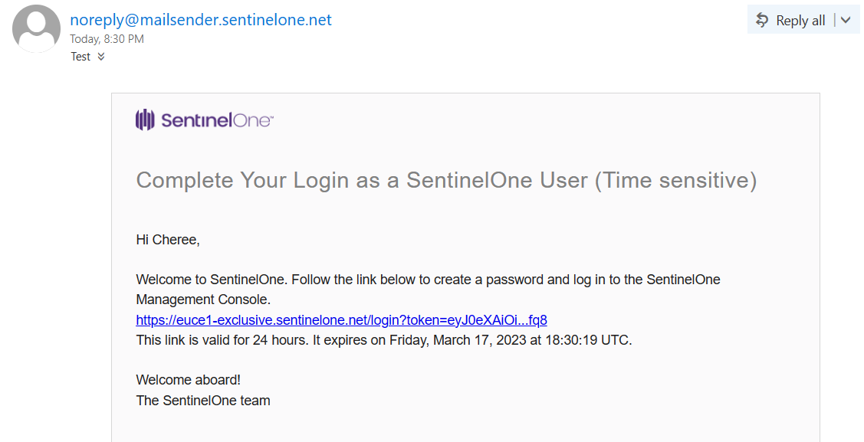

- Click on the link
- You will be redirected to the portal to “create a password”
- Type in a “password” and select “save”
- Type in the “email address” and “password”; click on “login”
- To log in to SentinelOne; you will need to install “Google Authenticator” (2FA is enabled on every user)

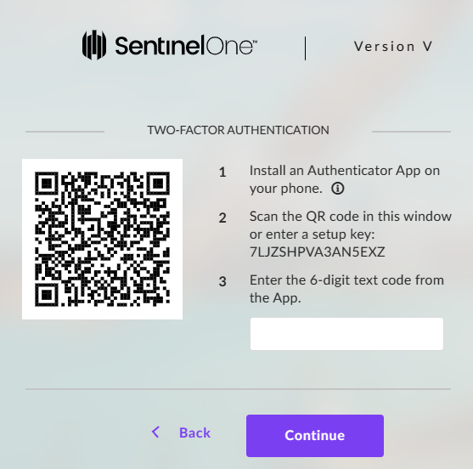
- Once logged in, you will see the below:

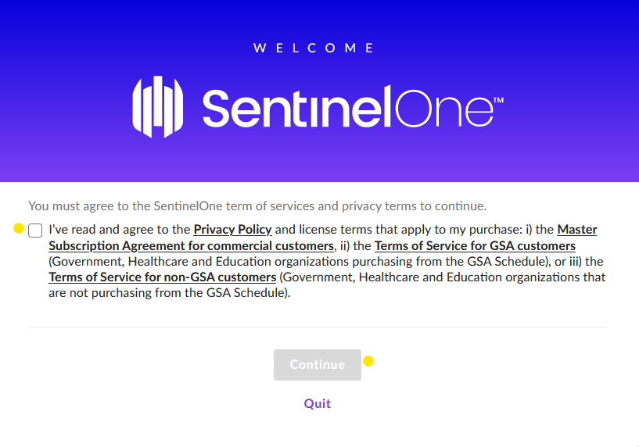
- Tick the box and click on “Continue” – see below “Dashboard”:

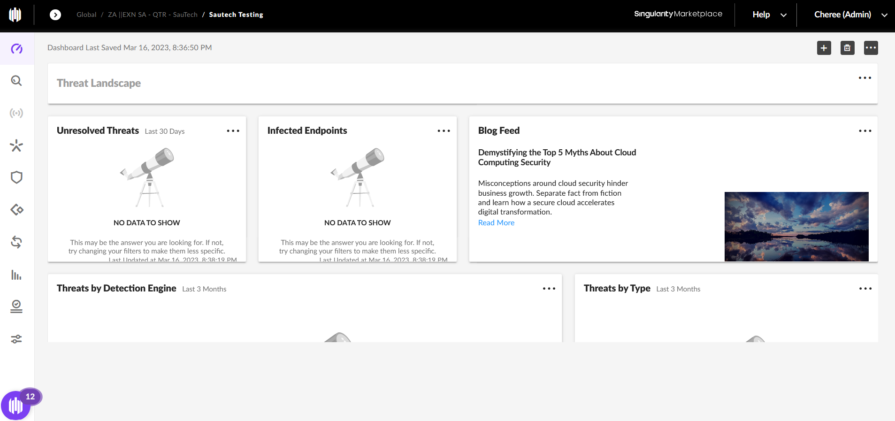

- On the left panel, find the following:

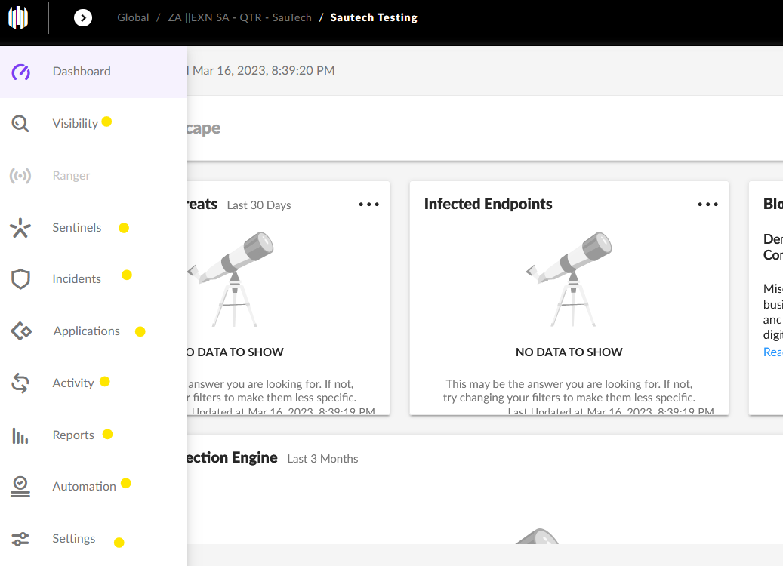

- “Visibility”: An endpoint protection solution that provides unparalleled search capabilities for all indicators of compromise (IOCs); regardless of encryption and without the need for additional agents.
- “Sentinels”: The endpoints loaded
- “Incidents”: SentinelOne provides AI-powered prevention, detection, and response across endpoints, cloud workloads, and IoT devices to stop and prevent incident responses. When corrective action needs to occur, SentinelOne can kill, quarantine, remediate or roll back any potential effects from the threat.
- “Applications”: The platform uses machine learning and other advanced analytics techniques to detect and block malicious activity in real time.
- “Activity”: Activity listed on each endpoint.
- “Reports”: This report provides visibility into the number of malicious and suspicious threats the team has detected and resolved.
- “Automation”: Sentinel One’s automated threat response capabilities are designed to respond automatically to threats in cloud environments.
- “Settings”: Configuration, notifications, users, integrations, policy override, sites, locations.

- TO INSTALL SENTINEL:

- Click on “Sentinel”
- Click on “Packages”:

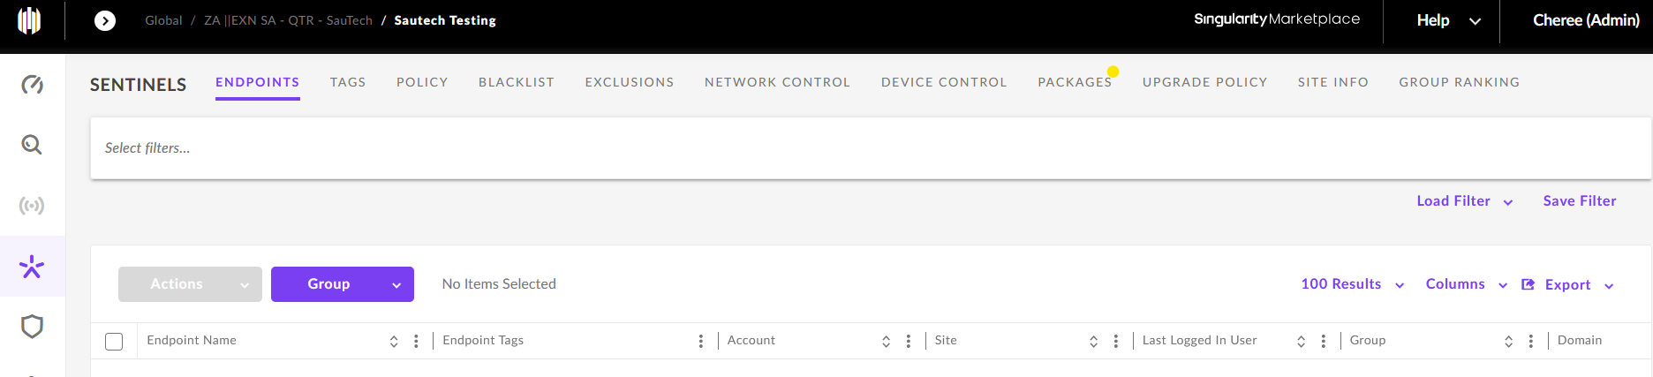

- Select the ”Package” you would like installed, click on “Download”:

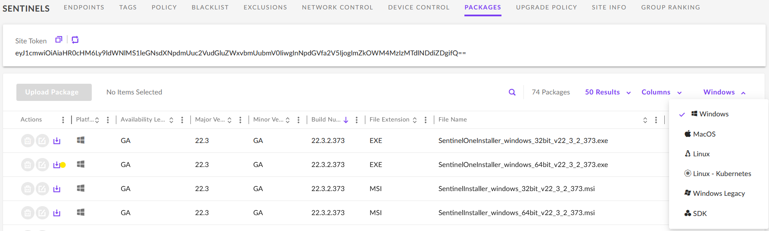

- “Site Token” must be entered during installation:

- Once installed, Endpoint will show in “Default Group”:

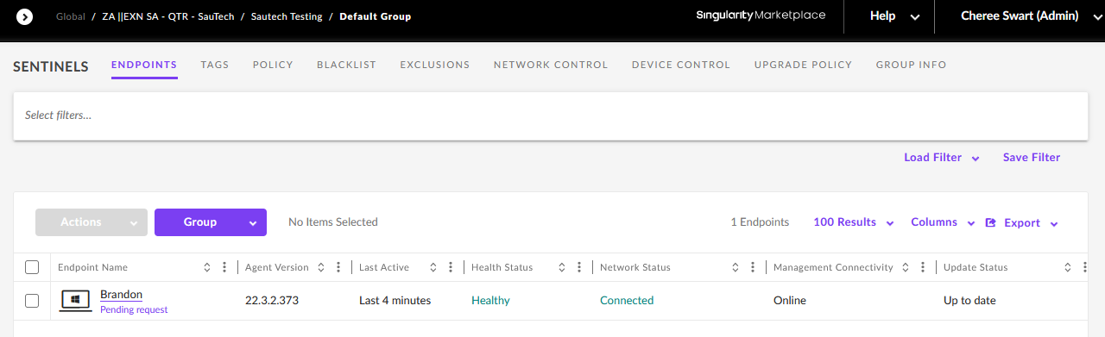

- Full scan will automatically start once the Endpoint has been loaded

- TO CREATE NEW GROUPS:

- Click on the “+” icon:

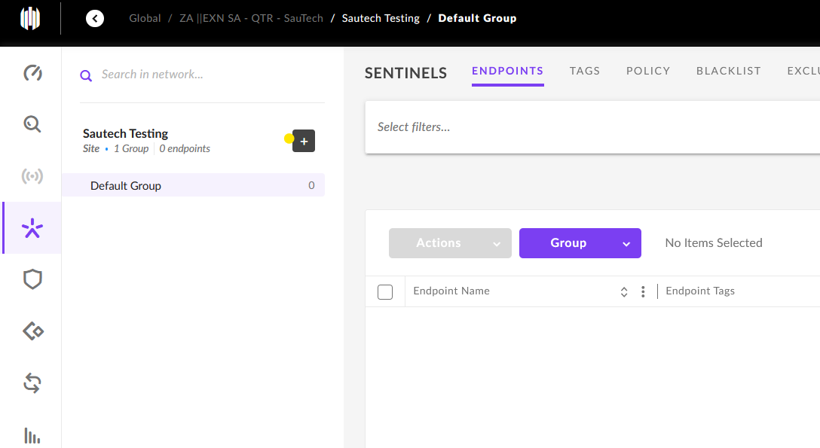

- Enter the “Group Name”
- Click on “Next”:

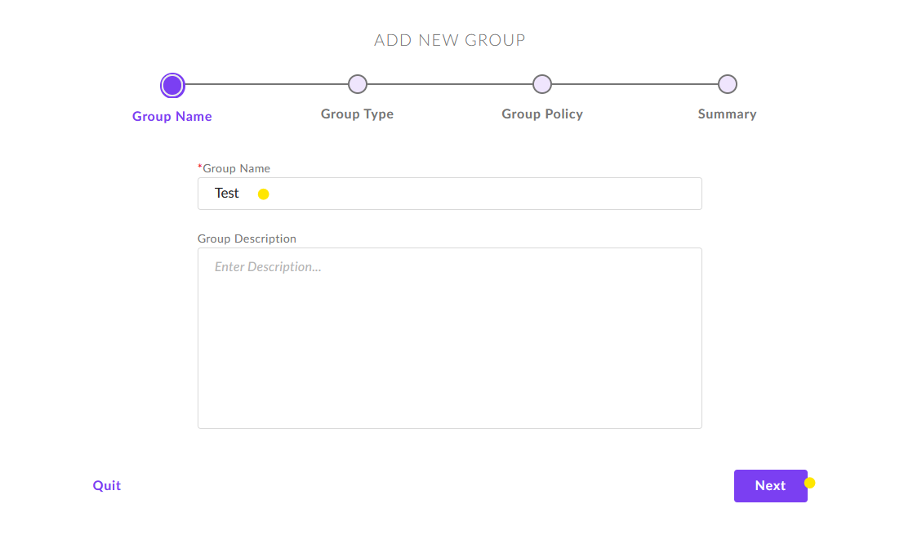

- Select “Manual Group”
- Click “Next”:

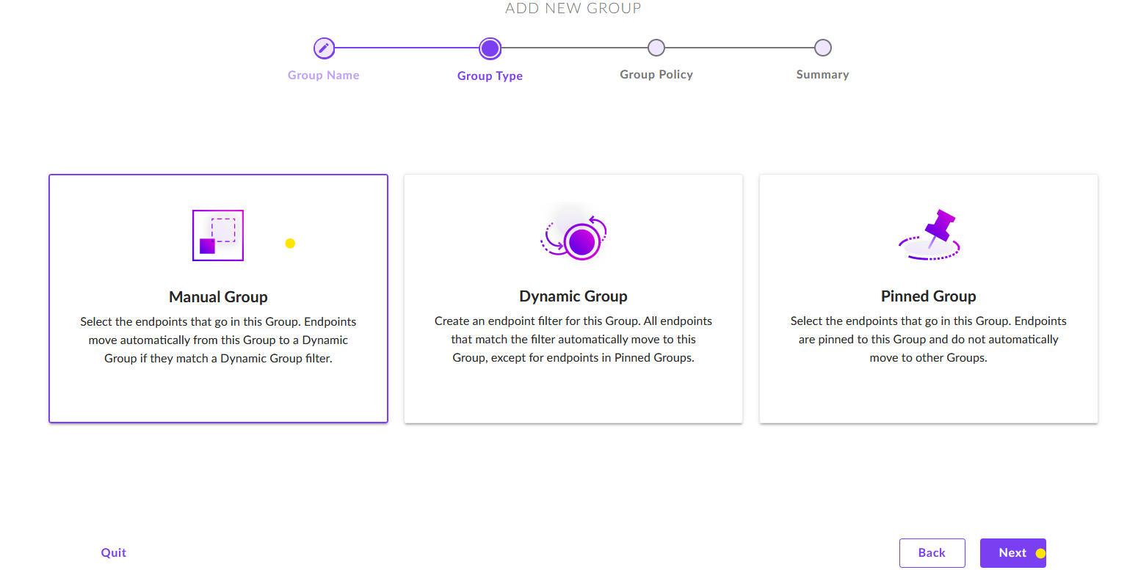

- To change the Policy, click on “Change Configuration”:

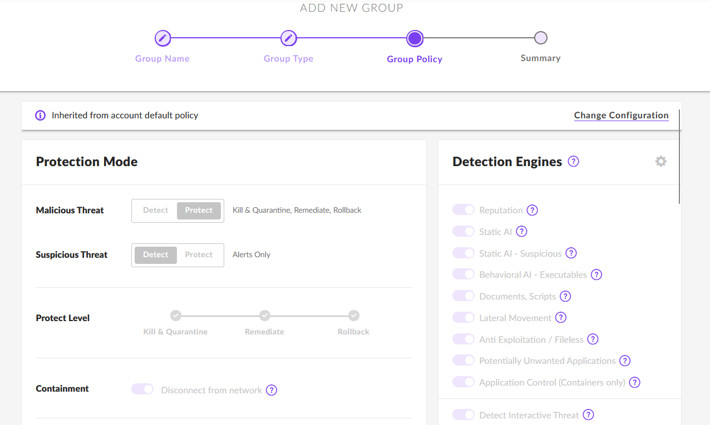

- Should no policy changes want to be made, scroll down and click on “Create Group”:

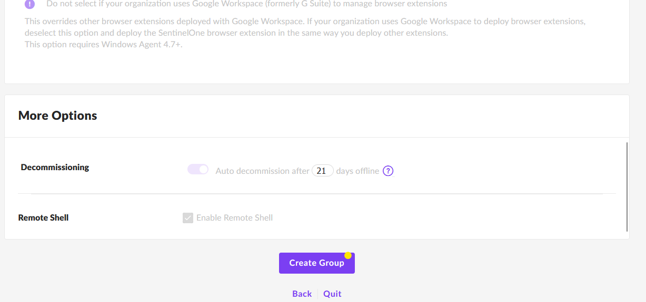

- Click on “Done”:

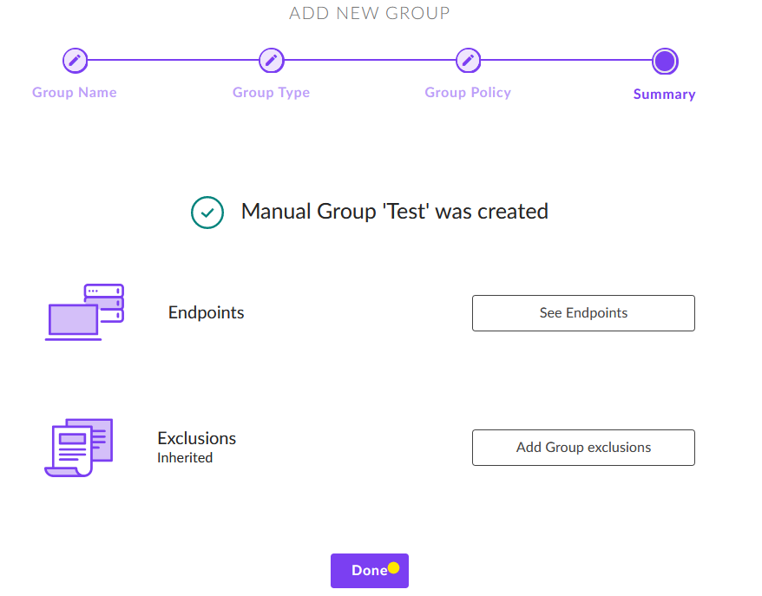

- Click on the arrow to show all groups:

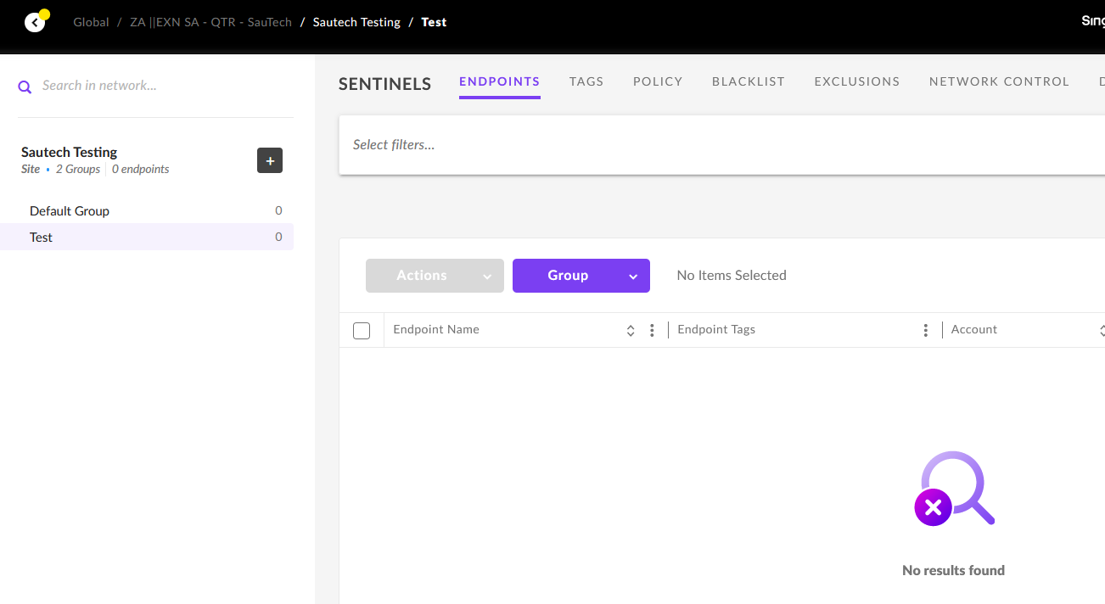

- TO MOVE ENDPOINT TO A GROUP:

- Tick the box of “Endpoint”
- Click on “Group”
- Select “Move to Group”:

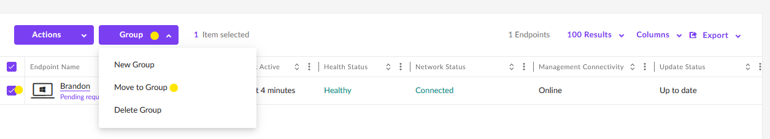

- Click on “Select Group”
- Choose “Group” from the “Drop Down”:

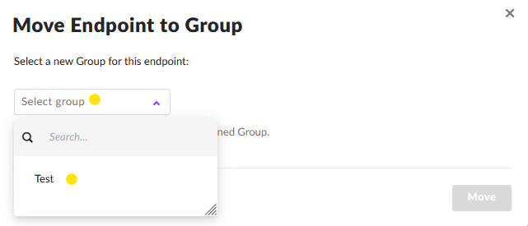

- Once the group have been selected; click on “Move”:

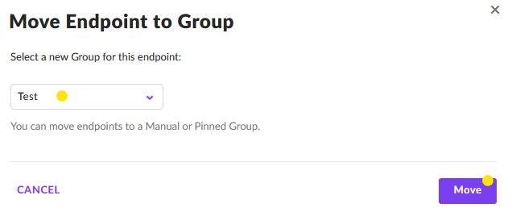

- Endpoint will then show in the “Selected Group”:

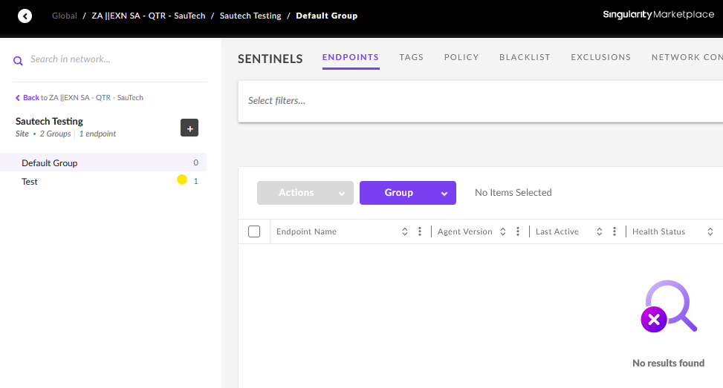

- WHEN CLICKING ON “ENDPOINT”; THE INFORMATION WILL SHOW:

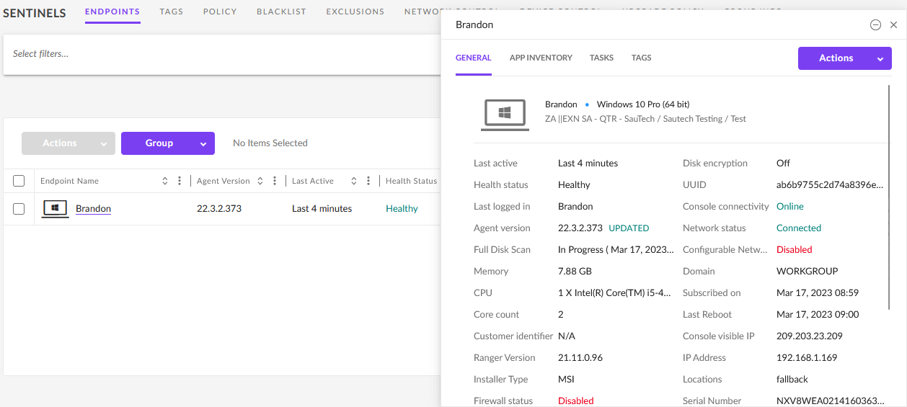
- Click on “Actions”, see below:

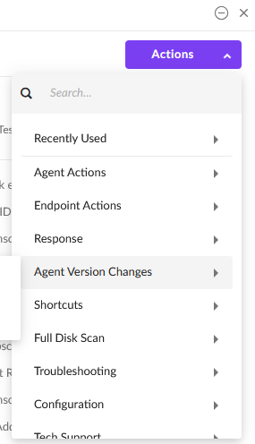
*Actions only appear when the mouse cursor is hovered over it

- Agent Actions:

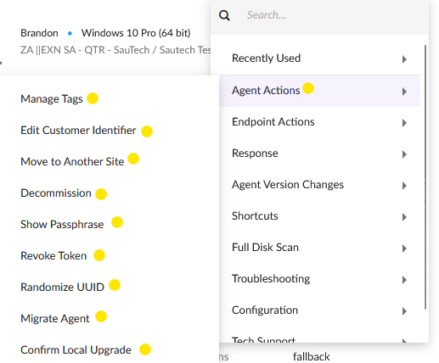

- Endpoint Actions:

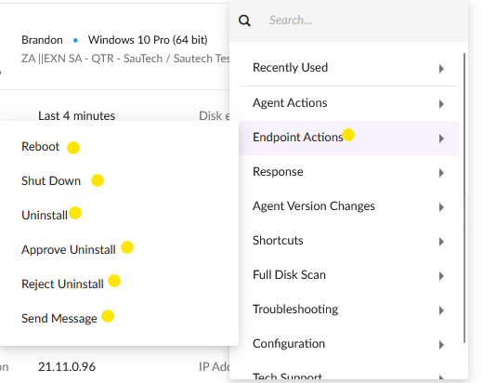

- Response:

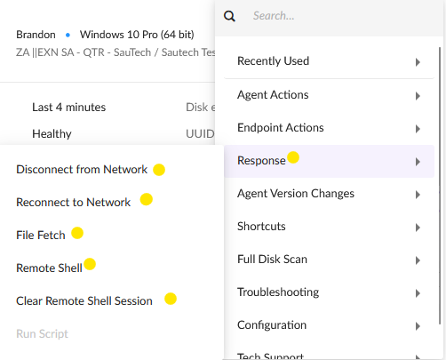

- Agent Version Changes:

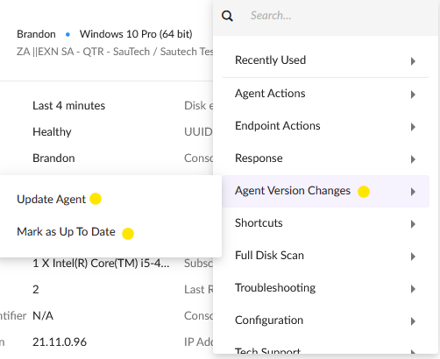

- Shortcuts:

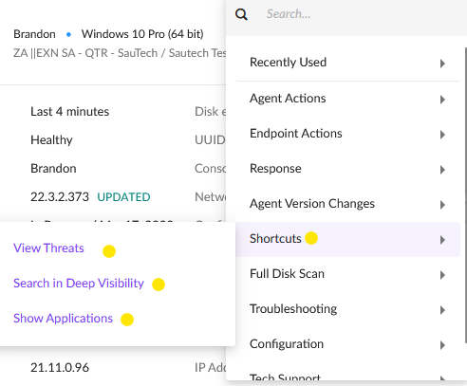

- Full Disk Scan:

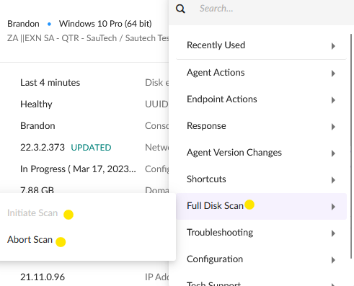

*Initiate scan is greyed out as a scan is already in progress

- Troubleshooting:

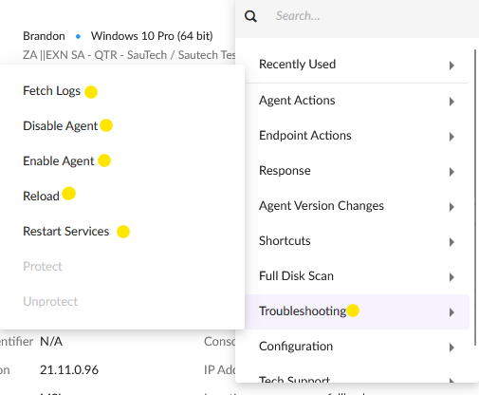

- Configuration:

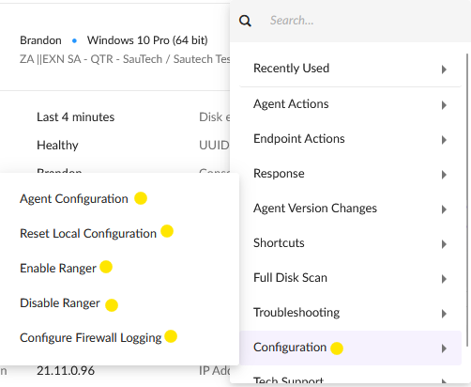

- Tech Support:

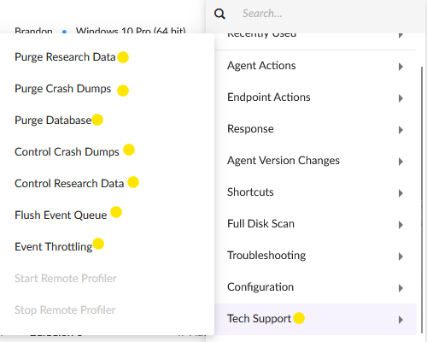

- POLICY:

- Each “Policy” can be changed per “Group”:
- To change the “Policy”, select the “Group”
- (At the top) Click on “Policy”:

- To change the “policy”, click on “Change Configuration”:

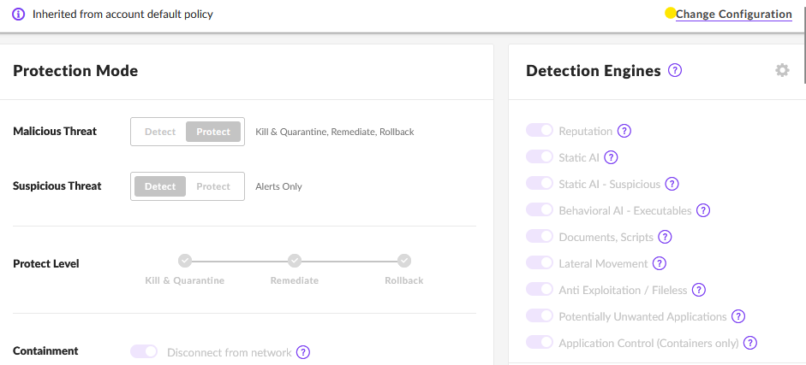

- Once the changes have been applied; click on “Save Changes”:

- BLACKLIST:

- “File/Programs” can be added to the Blacklist through “Incidents”
- On the “Selected Group” click on “Blacklist” next to “Policy”
- Select “Add New”:

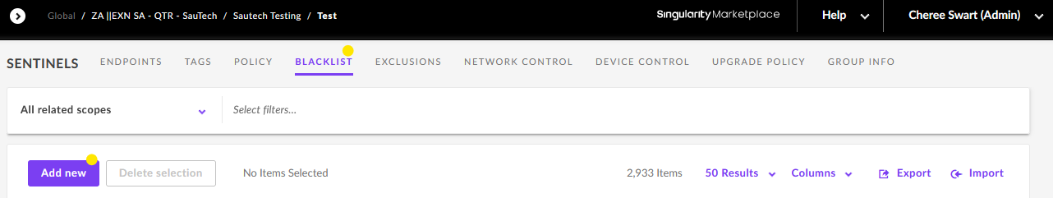

- WHITELIST:

- “File/Programs” can be added to the “Whitelist” through “Incidents”
- On the “Selected Group” click on “Exclusions” next to “Blacklist”
- Select “New Exclusion”:

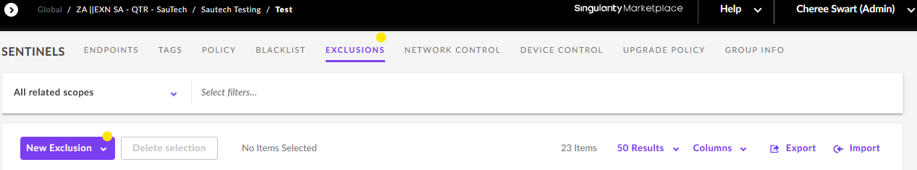
- TO UNINSTALL SENTINELONE ON AN ENDPOINT:

- There are three ways to uninstall Sentinel One on an Endpoint:

9.1 Uninstall through the “Management Portal”
9.2 Click “uninstall” command on the user’s pc/server (“admin” will have to approve the “uninstall”
9.3 Uninstall Online or Offline:

- Open CMD as “Administrator”
- Type in “File Patch” (Retrieve the “File Patch” through “File Explorer”)
- Click on “Enter”
- Type in “Uninstall” & “Passphrase” (“Passphrase” must be in “quotation marks”
- Click on “Enter”
- It will prompt to “Proceed with Uninstall”

- Example:

cd C:\Program Files\SentinelOne\Sentinel Agent 22.3.2.373
uninstall.exe /uninstall /k "Passphrase"

- If Endpoint was online; it will disappear from the “Management Portal”.
- If Endpoint was offline; you will have to decommission Endpoint from the “Management Portal”.

